Malaria detection from cell images using CNN

AI Final Project

Asad Sarwar(051-18-0003), Saffar Khan(021-18-0015)

BSSE-6

Table of Contents

**Abstract** 2

**Discussion** 2

**Dataset** 2

**Model** 2

**Frontend** 3

**References** 4

# **Abstract**

The project comprised of Malaria detection model from cell images using a convolutional neural network. The model is implemented with a complete frontend library Tkinter. The dataset usen in this project is provided by National Library of Medicine (NLM, 2020) with 27,558 images classified as “Parasitized” and “Uninfected”. The model is inspired from (sayannath)’s model for malaria detection using CNN. The accuracy of our model is 94.01% while (sayannath)’s model had more than 96% accuracy. Tkinter library is used for the development of user interface for this application. User can input multiple images at a time the result will be based on greater number images in a class.

# **Discussion**

The following is the details of dataset, model and front-end of this project:

## **Dataset**

The cell images dataset for training of the model used in this project is taken from (NLM, 2020). This dataset consists of 27,558 images in two classes named as “Parasitized” and “Uninfected”. These images were already split in 24,958 training and 2,600 testing images in train and test folders, respectively. Both train and test folders had two sub-folders named as classes.

## **Model**

The model is inspired from (sayannath)’s already built malaria detection model using CNN. The Figure 1 shows the summary of CNN model used in this project for malaria detection.

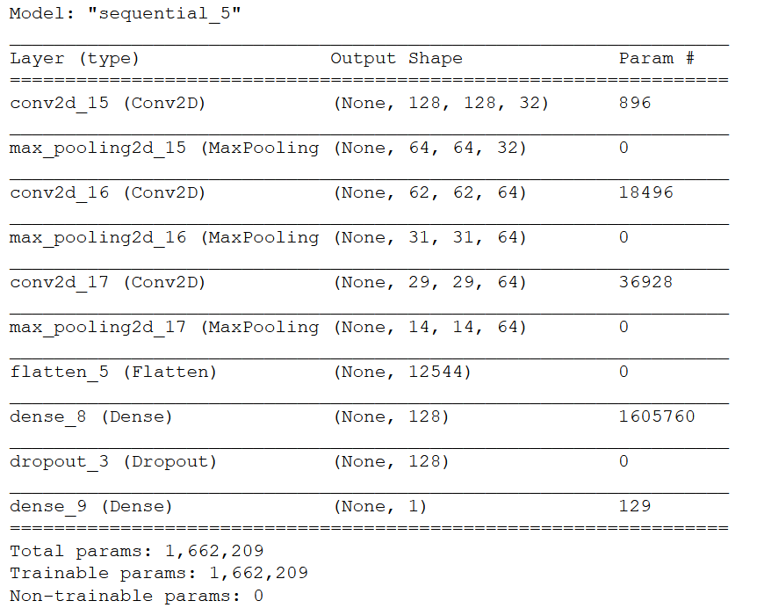

Figure 1: CNN Model Summary

Initially we ran 5 epochs that resulted in 92.21% accuracy. After that we increased number of epochs 5 each time and the accuracy were increasing with each increment in number of epochs. After 20 epochs the increase in accuracy was very small. At the end with 20 epochs, we got 94.01% accuracy, which is final accuracy of our model. While (sayannath)’s model had more than 96% of accuracy.

## **Frontend**

The tkinter library used to make GUI of project. GUI is user friendly and easy to use. User can do two actions while interacting with the system such as he can use application to get results of reports and information of system that how the system will be used. In Home section user will upload images from the system and will wait for the output of reports. The total output will be shown in the screen to analyze the reports from images. The system will show results either negative or positive. If the selected images/ reports have equal number of positive and negative results the system will show a messages that results are equal. Secondly in about section user will know that will the system do and how he can use the system. We have used these functions for GUI

Tkinter Functions used in GUI

Tk() to create frame and using its attributes such as obj.title() and obj.geometry()

Menu() for creation of menu bar

Label() for messages and information to users, attributes are obj.place()

Button() to perform actions from user, attributes are obj.grid() and obj.bind()

forget() to hide the widgets from frame and display new widgets in the window/frame

Obj.mainloop() it is used to run and display window in screen.

# **References**

NLM. (2020). cell_images. 2020, from https://lhncbc.nlm.nih.gov/publication/pub9932

sayannath. Malaria Detection using CNN. 2020, from https://github.com/sayannath/Malaria-Detection-using-CNN